Master Swap Parts List
(-) means acquired
tools
-engine brace
-2 more jack stands
-flywheel lock tool
-24mm 12 point socket for axle bolt

parts
-6spd 02q tranny
-tranny bracket where bfi mount attaches to
-tranny fluid and drain plugs
-6spd axles
-new bolt/washer kit
-brake and clutch pedal
-master cylinder
-starter
-shifter boot/trim
-shift knob
-Diesel Geek Sigma6 short shifter
-shifter assembly/box
-shifter linkage/cable bracket
-shifter cable bracket c clip – part number 1j0711280c
-FSI Flywheel - 6 bolt only
-Clutch – BFI/competition clutch
-OEM throwout bearing/slave cylinder
-2.0 clutch line (USP SS line, from master to bleeder/slave)
-2.0 bleeder valve for clutch line – ECS modified
-lower coolant hoses x2 and coolant flange– standard rabbit 5speed oem. Eliminates tranny cooler
-brake fluid
-brake master to clutch master line (brake master has nipple, needs to be cut)
-clutch position sensor – just the clip (sensor is on master cylinder)
-reverse light sensor
-pins and wire to hook up clutch position/reverse light sensors (0.35mm squared wire)
-tranny mount (have BFI)
-dobone mount (reuse from auto)
-BFI engine mount
-tranny bellhousing to motor bolts, mix and match from 6 speed
- a bunch of random bolts
-Bentley manual
-wire and code clutch position sensor – there is some overlap with the auto transmission so some wiring is accessible from the engine compartment
wire and code reverse light switch – pin out from the auto trans.
new UM tune/ECU

Tips and Shit

Axle bolt torque specs
If you have the 12 point bolt w/o washer - 52 ft-lb (70 Nm) + 1/4 turn (always replace)
6x m8/m10 triple square axle bolts: First tighten to 7 ft-lb in a diagonal pattern. Then tighten to 30 ft-lb (40 Nm) if you have a manual, or 52 ft-lb (70 Nm) if you have a DSG with the M10 bolts. Tighten the bolts in a diagonal pattern then double check because these like to come loose.
3x 16mm ball joint bolts: 44 ft-lb (60 Nm) (always replace)

Wiring Changes
Two major wiring changes need to be done
- Wire up the Reverse Light Switch on the shifter
- Wire up the Clutch Position Sensor (G476)
Wiring up the Reverse Light Switch
Here is the Wiring Diagram for the reverse light switch
The switch is F4.
This shows that
Pin 1 on the switch goes to A20
-A20 is a 15a power source, splice into the Glove compartment light and A/C connection.
-Pin 2 on the switch goes to Connector F Pin 6 on the J519 (CECM).
Clutch Position Sensor
How to do it the OEM method. In order to start the car, requires you to depress the clutch and then turn the key to start.
The only thing required to do this is to wire up the Clutch Position Sensor (G476) Properly.
Here is the Diagram of the Sensor
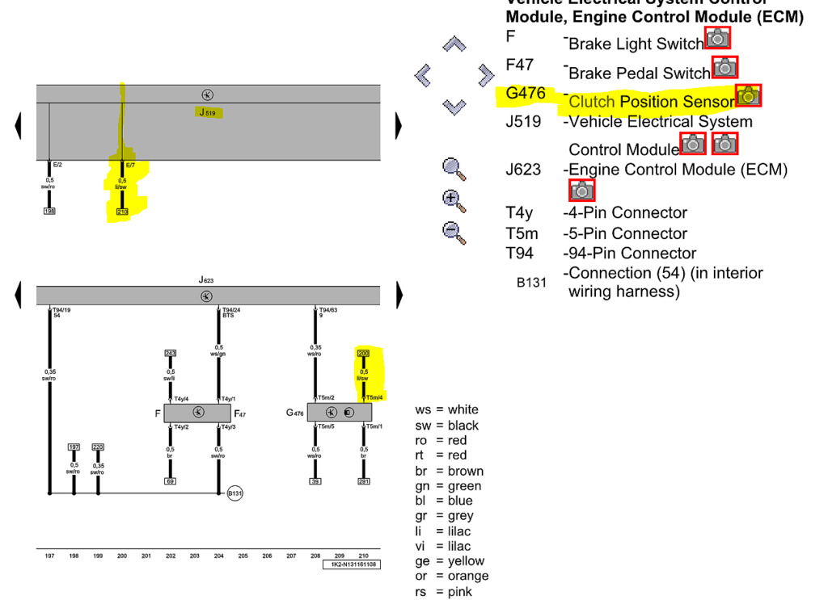
Find the G476 on it, That is the Sensor.
In case you do not know how to read this diagram i'll give a little explanation of where each wire goes to. At the end of each wire is a number. Take for example the one i highlighted. At one end there is a box with 200 in it, on the sensor side there is one that says T5m/4. The 200 you need to find along the bottom of the picture and find the matching wire that says 210, which is also highlighted. The T5m/4 means that the plug had 5 pins or "Terminals", which the G476 does have. Terminals 1, 2, 4, 5 are used as 3 is not. The /4 means its Terminal 4 out of the 5 pins. So Pin 4 of the Clutch position sensor goes to Pin 7, Connector E of the J519(CECM).
So here is how the pinning goes:
Pin 1: Ground, you can ground this out anywhere you like on the car.
Pin 2: The 94 Pin connector its Pin 63, there is already a wire in this pin, just cut it and splice the wire from Pin 2 of the Clutch sensor into it.
Pin 3: NOT USED
Pin 4: Connector E, Pin 7 on the J519(CECM) This Pin is also occupied(It was on my car) Just cut it and splice the wire from the Clutch sensor into it.
Pin 5: Power, you can hook this up to any switchable 12v power source. If you would like to wire it to the Fuse box correctly see below
How to get the Clutch Sensor Power THE CORRECT WAY!
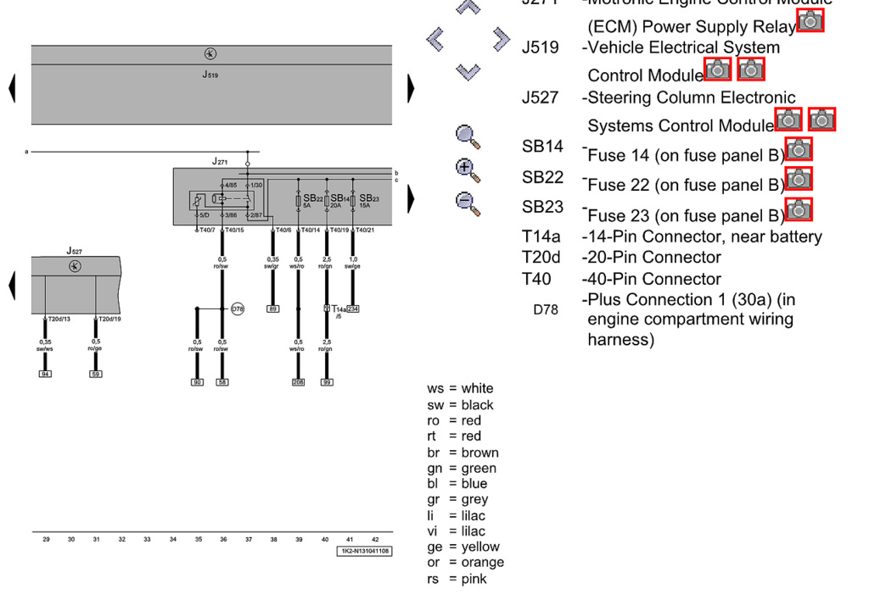
If you look on the Track at the bottom and locate 39, its also gonna be the wire that has 208 in a box. That wire goes to a 5amp fuse the SB22 Now if you disassemble your fuse box and take the big 40 pin connector out this is where we will be plugging in the wire. I used a repair wire I had laying around that fit into the hole of the connector. You want T40/14. So you will plug the wire from Pin 5 of the Clutch sensor into Terminal 14 on the plug for the fuse box.

Clutch position:
You need to provide the switch with a switched +12v and ground.
One signal goes to the ECU (all new wire) and the other is spliced into the wire that went to your auto transmission range switch, the "park" wire or pin 2. Hopefully you set that one aside when cutting you harness, it might be hard to find in the bundle. If you already cut it not the color of the wire on the transmission plug and try to find that in the bundle.
The reverse switch is all new wire,
Pin 1: Fuse Panel C SC4... well kinda. There seems to be a Plus Connection 8 (in instrument panel wiring harness bentley says) it's connected to.
Pin 2: CECM F-6 (doesn't exist in autos so it needs to be routed)

Ok so Pin 2, by the 94 Pin connector its the 94pin connector at the ECM. The ECM is in the rain tray. One of the plugs is for the engine harness the other is the body harness of the car. the 94 Pin connector is the body one.
Pin 4 If you look at the CECM each connector will have a letter next to it. its kind of hard to find but you'll see it.
Pin 5 the plug is under the big fuse box in the engine bay.

